PRE-MODEL EXAMINATION

NAME:T.Vamsi krishna

REG NO:192224122

Q.NO:1

#include<iostream>

class circle{

private:

double radius;

public:

void setradius(double r){

radius=r;

}

double getradius(){

return radius;

}

double calculatearea(){

return 3.14\*radius\*radius;

}

double calculatecircumference(){

return 2\*3.14\*radius;

}

};

int main(){

circle c;

double r;

std::cout<<"enter the radius of the circle: "<<std::endl;

std::cin>>r;

c.setradius(r);

std::cout<<"area of circle: "<<c.calculatearea()<<std::endl;

std::cout<<"circumference of a circle: "<<c.calculatecircumference()<<std::endl;

return 0;

}

OUTPUT:

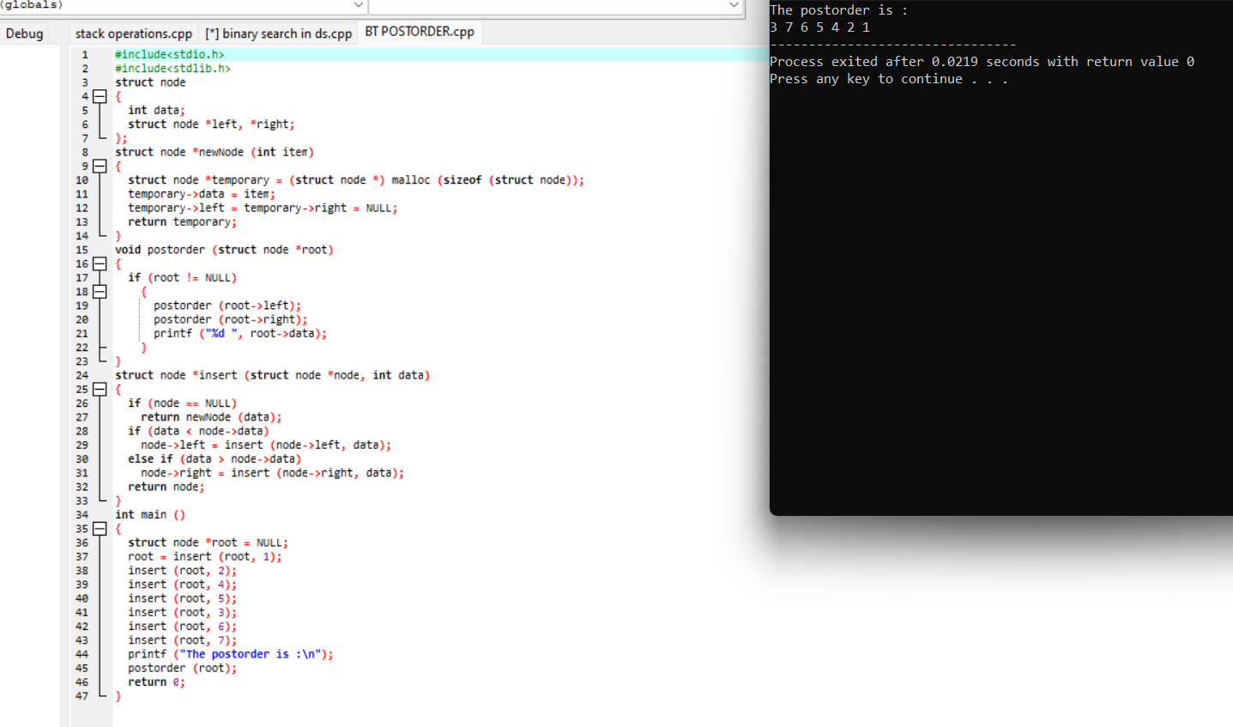

Q.no:2

#include<iostream>

using namespace std;

int main(){

int n;

cout<<"enter the number of rows: "<<endl;

cin>>n;

for(int i=1;i<=n;i++){

for(int j=1;j<=n-i;j++){

cout<<" ";

}

for(int k=1;k<=i;k++){

cout<<"1";

}

cout<<endl;

}

return 0;

}

OUTPUT:

